

**Software Engineering and Testing. BSC Year 2, 2020/2021**

**(Assignment 2 - 20%)**

**Assessment 2: Requirements Document**

**Submitted by:**

**Adam Ennis B00152710**

**Sean Doyle B00156175**

**Alex Dela Cruz B00149504**

**Submission date**

**Declaration**

I herby certify that this material, which I now submit for assessment on the programme of study leading to the award of Ordinary Degree in Computing in the Institute of Technology Blanchardstown, is entirely my own work except where otherwise stated.

Author: Adam Ennis Dated: 11/02/2024

Author: Sean Doyle Dated: 11/02/2024

Author: Alex Dela Cruz Dated: 16/02/2024

**Table of Contents**

Table of Contents

Title 4

Client 4

1. Project Overview 4

2. Document Revision 4

3. Scope 4

5.1 User Requirements 7

5.2 System Requirements 8

5.3 Non-functional Requirements: 10

6. Graphical User Interface Design 10

7. Technical Requirements and Feasibility: 12

Development Language: 13

Persistent Storage: 13

Interface & Software / Hardware APIs: 13

8. Conclusion (1-2 paragraphs) 13

# Title

Tailored Suits Blanchardstown Online Store (Online tailored suit site).

# Client

Paul Duffy

Tailored Suits Blanchardstown.

# Project Overview

The project definition:

* The project involves developing and testing a website for a suit company.
* The website will allow users to search for specific brands of suits, log in, browse categories of suits, and add items to their basket.
* Main components will be a search bar, customer sign up/in area, shopping basket and a navigation bar.
* The website will be used mainly by businessmen looking for suits or men looking for suits for occasions.

# Document Revision

1.0 (09/02/24) – Need to make 5 and 6 made

2.0 (15/02/24) – Made 5 and 6; Need to make conclusions for rev 2.5

# Scope

The desired functionality is as follows; we intend to include the following:

* Search bar area, to allow the user to search for specific brands of suit without having to scroll through pages to find the suit.
* Customer log in area, the customer will be able to log in and if they are a first-time customer, they will be offered a measuring kit with they’re first order.
* There will also be a navigation bar with categories of suits for customers who aren’t sure and just want to browse.
* A shopping basket will be present on all pages to allow the user to view any items added and remove any items added if necessary.
* When signing up user will get brought to a sign-up page initially and asked if they have an account already, if so, they will be brought to another page for sign-in

We were looking to add more functionality, however the functionality we have included will make the website work fully for the customer and user side. Some of the functionality we were going to introduce but decided holding back on were as follows.

* We were going to add in a sign in bonus but decided against it as this is an organizational decision rather than a programmer.
* We were going to display a video of how to measure yourself on the pages with tailored suits, however decided against this and came up with a home solution, a package containing a leaflet with instructions, measuring tape and photos on the leaflet to fully explain what measurements are needed and where. We now just need input in five places for measurements.
* We didn’t implement reviews as the review wouldn’t be accurate due to the nature of the business (Tailor).

1. **Walkthrough Scenarios**

People that are going to interact with the website will be customers of our client, these customers mainly being business men and men looking for a suit for any occasion, weddings, debs suits , communion , confirmation and many more.

There will be two main ways of using the website; the tailored ‘side’ of the website and untailored ‘side’ of the website; to use the tailored ‘side’ of the site you must purchase or own a ‘fitting kit’ and have taken the necessary measurements, which then will be inputted into the website and the company tailors will make the suit based off these measurements.

For the non-tailored ‘side’ it will be slightly easier there is generic sizes along with generic fits (slim fit, wide fit, long fit, etc), all the users must do is base their fit off the given images of body sizes:

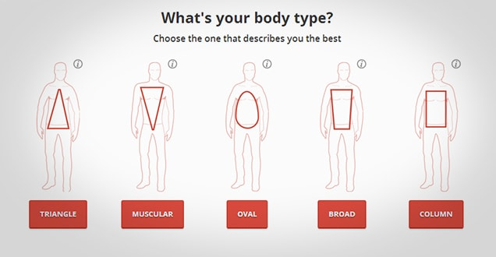

(JoeButton.com, 2024)

Once they have chosen their suit, they will choose a generic size then towards the end of the page they will choose their body shape and the tailors/employees will choose the suit based on the given info.

1. **Software Requirements Analysis:**

***Functional Requirements:***

These are statements of services the system should provide – how the system should react to particular inputs and how it should behave in particular situations. Explicitly state what the system should do. Every major scenario should be represented by a use case. Diagrams are encouraged. UML Use case diagrams, Use case specifications (as legible screen dumps, typed listings or activity diagrams)

Can approach them from a *user* and *system* point of view.

*User* – high level abstract requirements, readable by someone with no detailed technical knowledge.

*System* – detailed description of what the system should do. Targeted at technical staff and project managers…

e.g.

# 5.1 User Requirements

* **Functional Requirements**
  + Customers should be able to access the website by searching in on the Internet from a laptop or computer or mobile device.
  + If you would like to make a tailored suit there should be some instruction on how to input the measurements in properly.
  + Customers should be able to input their measurements manually or by using interactive tools such as a slider bar.
* **User Interface Requirements**
  + The User interface should be intuitive and user-friendly.
  + The website should be accessible on different screen sizes such as a laptop, Desktop, Tablet and smartphone.
* **Performance Requirements**
  + The website should load quickly and respond promptly to user interactions.
  + The website should be able to handle high levels of traffic without going down.
* **Usability Requirements**
  + When a customer is using the website, it should be straightforward.
  + The nav bar and search bar should be able to be found with ease.
  + Once the nav bar is clicked it should show clear indicators to either regular suits or tailored suits.
  + Once one is clicked it should bring you to the tailored suit or regular suit page.
  + If the customer is buying a tailored suit the measurements should be easy and straightforward to insert in.k/
  + Once satisfied with the suit you should be able to insert it into your basket.
  + When you are ready to pay the customer can either login or register.
  + Once all is completed the Customer can now purchase their new top quality tailored suit from the comfort of their own home.

# 5.2 System Requirements

5.2.2 Use Case Specification

|  |  |
| --- | --- |
| Login: | * Customers can log in to the system using their user and password * Authentication request gets sent to the database to confirm customer details * Authentication verified. * Purchase history for logged in customers gets stored in the database |
| Shipping + basket: | * Shows items with quantity and price and total. * Selecting “pay now” will direct users into the shipping page. * IF logged in, option to use user address or another. |
| Home Kit + Measurements: | * Customers have a choice to get custom tailored suits ONLY from the “tailored suits” option. * Input own self measurements. * On tailored suits page, pop up menu shows for a home measurement kit.   If No  Prompt to buy measuring kit.  Else  Return to tailored store. |
| Stores (Not Tailored): | * Store to shopping basket if put to basket. * ONLY has Small, Medium, Large. * Refine search/filter to select different body types (radio) * Refine search/filter to select colours (checkbox) |

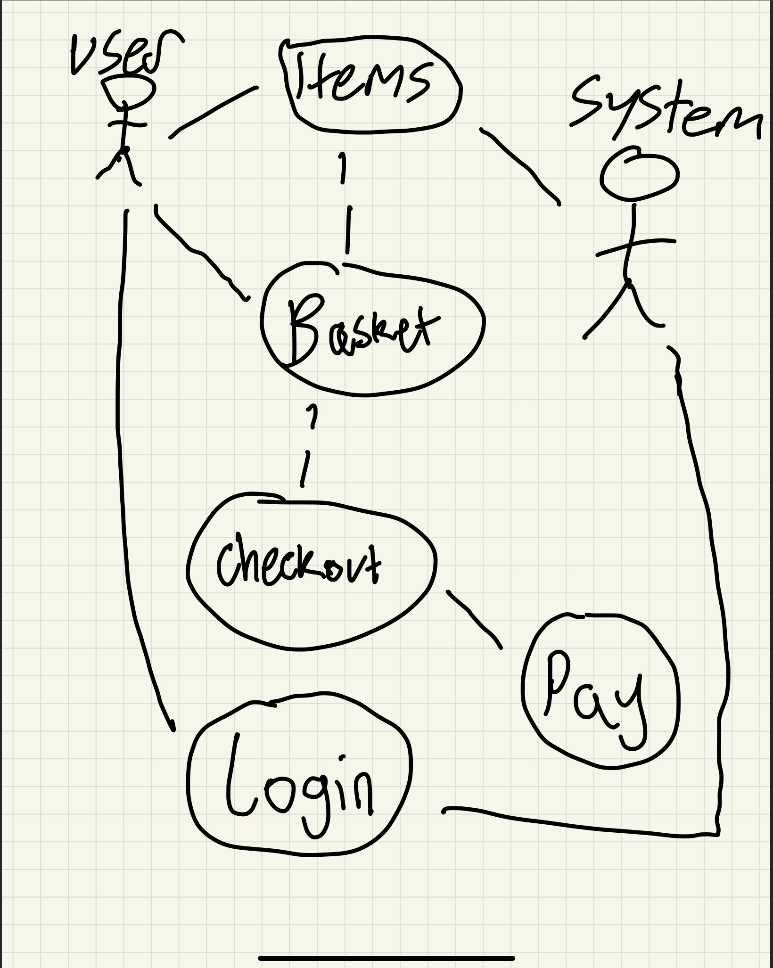

# 5.3 Non-functional Requirements:

These are constraints on the service or functions offered by the system e.g. timing constraints

* Need images of suits.
* Need a gallery to display images for the suits.
* User must know how to shop online.
* User can make a profile to store previously entered data, give the user minimal work.

# Graphical User Interface Design

* Home Design

Implement a responsive navigated web design with the home page greeting people with 3 choices:

* Best Sellers
* Custom Tailoring
* Store
* Browsing design

The design of the browse can be a 3 column / 1 column scroll down with a filter of suit components on the side / top.

* Logging in/signing up Design

User login/sign up should implement as sliding interface that will allow the user to switch between signing up or logging in with ease.

* Nav Bar

Nav bar should have sub nav bars in them.

* Shopping Cart

Shopping cart must have the ability to remove orders from them and have the price of each of the suits/suit components. The shopping cart should also include the total price of the purchase.

* Shipping design

The Shipping page should have a form that will include the customer’s name, email, address and Eircode.

There are wireframes of the home and store page included to start to give an idea of how the website will look and feel, see the next page.

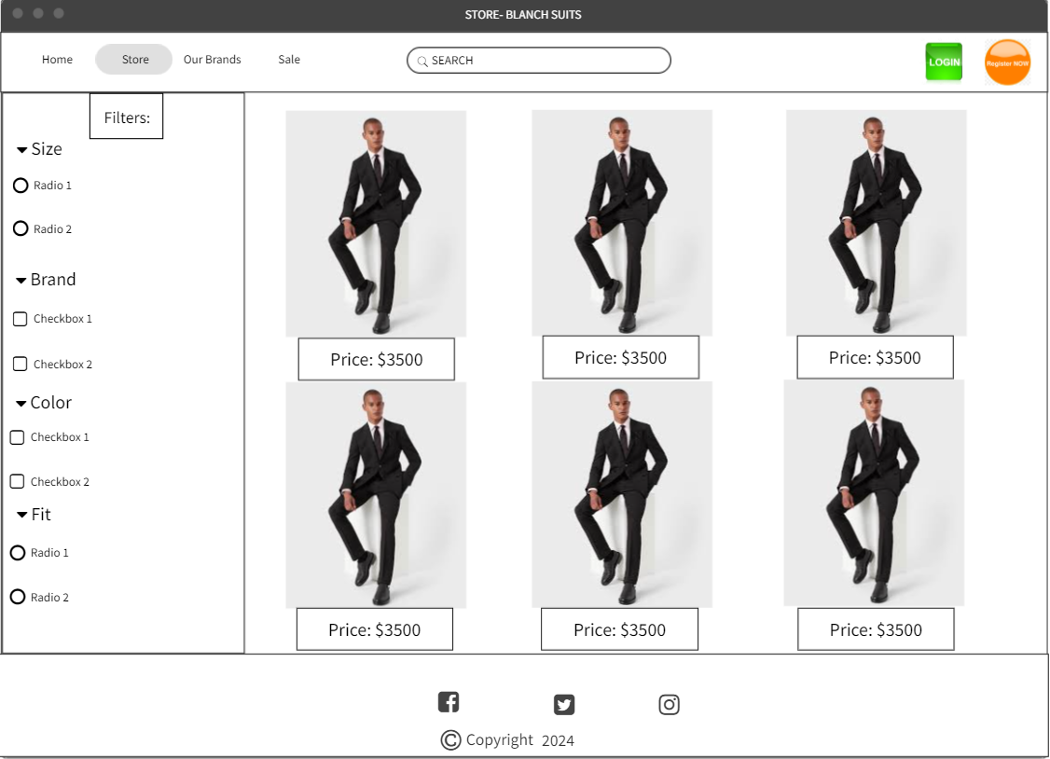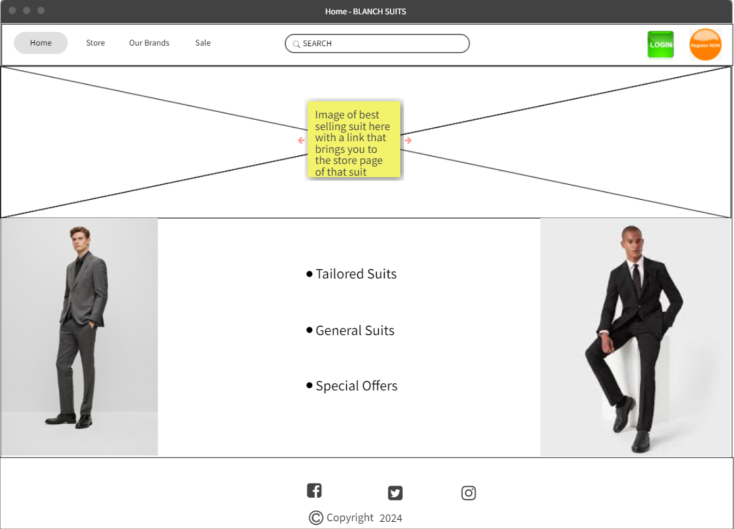

# Technical Requirements and Feasibility:

This product will be designed using UML diagrams, for the methodology we are using the AGILE method because it allows us to break the project into phases and emphasize collaboration and enables us to gather feedback early and often. Our team will follow a cycle of planning, executing, and evaluating. We do this through our weekly Scrum meeting. 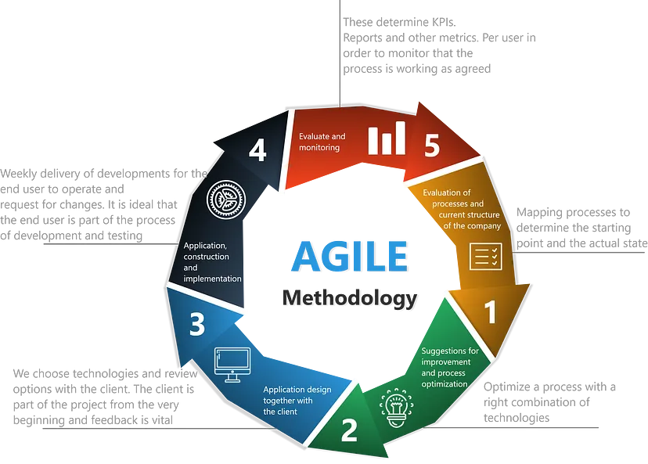

(Medium.com, 2024)

It will be written in multiple languages including PHP, SQL, CSS, JavaScript and HTML.

* PHP: Chosen as the primary language as it is a widely used general purpose scripting language, PHP also facilitates the communication to our chosen database. PHP is an interpreted language, which means it is executed line by line rather than compiled, this allows for quick debugging.
* SQL: Used for interacting with (storing and receiving data) and creating databases. Crucial for storage of website data.
* CSS: Used for styling the website and making it look appealing.
* HTML: Works hand in hand with CSS and JavaScript to create the webpage.
* JavaScript: Adds interactivity to the website and dynamic behaviour.

# Development Language:

PHP has been chosen primarily due to its versatility in web development. One of the main advantages of PHP is its compatibility on various operating systems so long as PHP is installed it doesn’t matter if its Windows, Mac Linux, or mobile devices.

For development we will be using Visual Studio Code IDE as it provides plenty of features to help with PHP development, such as code completion, debugging tools and highlighting syntax errors.

# Persistent Storage:

MYSQL will be used for storage of any areas necessary on the website.

Our website will connect with the SQL database through PHP, we will be able to query the database using PHP and return data to the website. This interaction will help with retrieval and displaying information about the website and products.

# Interface & Software / Hardware APIs:

This Programme will utilize the languages mentioned above to create a user-friendly interface and an easy-to-use design, we will also incorporate the fact users may be viewing the site on different size screens and adjust the design accordingly.

For the API’s we will be using a log in function to allow the user to log in, so they don’t have to re-enter information.

## Conclusion (1-2 paragraphs)

Your conclusions and recommendations (feasibility of the proposed project)

Additional sections: Table of Contents, executive summary, Index

Checklist: Is your document complete and correct?

*Content:*

* Do the requirements state the customers’ needs
* Are you satisfied with all parts of the document
* Do you believe all parts are possible to implement
* Is each part of the document in agreement with all other parts
* Do the requirements avoid specifying a solution
* Do the requirements avoid specifying a design

*Completeness*:

* Are all the necessary interfaces specified – this includes input and output
* Are the specifications precise enough
* Are all sections from the document template included – if changed, why?

*Clarity*:

* Are all requirements reasonable?
* Is the level of details for each requirements appropriate?
* Are the requirements written in a language appropriate to the reader?
* Are all items clear and unambiguous?